**AcqManager**

**Menu Tool Guide (*Wireless and/or Wires*)**

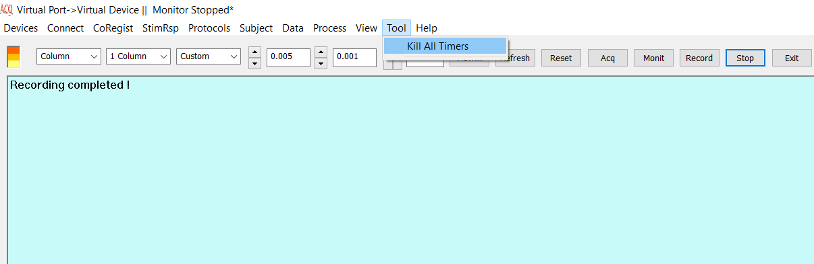

DISCLAIMER

We have used reasonable effort to include accurate and up-to-date information in this manual; it does not, however, make any warranties, conditions or representations as to its accuracy or completeness. We assume no liability or responsibility for any errors or omissions in the content of this manual. Your use of this manual is at your own risk. Under no circumstances and under no legal theory shall the authors be liable for any indirect, direct, special, incidental, punitive, exemplary, aggravated or consequential damages arising from your use of this manual.

Features and specifications of this software program are subject to change without notice. This manual contains information and images about AcqManager, its user interface, GUI and its other signal processing algorithms, publications that are protected by copyright.

All rights reserved. This publication may be reproduced, stored in a retrieval system, or transmitted, in any form or by any means, electronic, mechanical, photocopying, recording, or otherwise, with prior permission by the authors.

*Sending Your Comments and Critiques:* We’d like to hear from you. Your comments and suggestions for improving this document are welcome and appreciated. Please e-mail your feedback to support@mecurer.com

Thank you.

Contents

*Warnings and Cautions* 4

Preface 5

Kill All Timers 6

# *Warnings and Cautions*

This software supports data acquisition for magnetoencephalography (MEG), electroencephalography (EEG) and other bioelectromagnetic signals. Though MEG and EEG waveforms appear similar, they have different unit in amplitude. If the MEG and EEG data recorded simultaneously, their time unit or temporal resolution is typically the same.

Modern MEG/EEG systems typically have MEG/EEG sensor/electrode channels as well as other channels. For example, trigger channel, head-localization channels and additional ADC (analog-to-digital) channels. To avoid problems, please pay attention to the channel names and the amplitude value/unit. Their values may be of different orders of magnitude. Unexpected results may occur if their values are mixed in measurements.

When performing waveform analysis, regardless of whether MEG or EEG or both are displayed, ensure that the data are appropriately filtered with DC-offset/linear-trend removal. If the waveforms had very large amplitude (e.g. > 3 pt), it is recommended that you identify possible noise.

There are a set of source localization algorithms in the program. Each source localization algorithm has been designed and tested for specific reasons. To ensure the quality and visibility, all source localization algorithms will generate a volumetric source image, which can be considered as an image with millions of “dipoles” or multi-value-voxel, which is significantly different from the conventional magnetic source imaging (MSI) or equivalent current dipoles.

Head movement during MEG recordings may affect the accuracy of source imaging. If subjects move too much during MEG recordings, the MEG results are more than likely poor.

The accuracy of the structural images (MRI/CT) may also affect the MEG results if the conventional magnetic source imaging (MSI) is used. If MRI/CT is distorted, the combination of MEG/MRI/CT will be low-quality. In addition, multiple local sphere, head model or other structural constrained source localization my internally use the MRI/CT images. Any analysis based on those distorted images may yield unexpected or poor results.

The following warnings and cautions appear in this guide. Please ensure you are aware of all the operations and interpretations.

# Preface

The Main Frame is one of the core windows of AcqManager software. It is used as the primary tool to view MEG, EEG, MCG, ECG, triggers and other data, mark and classify the data, and identify results of interest for academic or clinical purposes. Importantly, the Main Frame provides graphic user interface (GUI) for access other function. In other words, it is also often used to launch other windows such as source localization.

This guide describes the operation of the AcqManager application for MEG/EEG/MCG/ECG. Though there are many functions related to MRI/CT, analyses of MRI/CT are not the focuses of this guide.

*Determining the Software Version*

In the Main Frame: select Help -> About.

The About Dialog will show the version of the software.

*Intended Audience*

This guide is intended for anyone needing to record and view (online) data with an appropriate hardware system. It assumes the technologist/operator is familiar with standard MEG/EEG/MCG/ECG procedures and with the Windows operating systems.

*Document Structure*

Documents are generally provided in both Microsoft Word® format and Adobe® Acrobat® PDF (Portable Document Format). All editions are distributed on Flash Driver, CD or websites with the related software, and include bookmarks and hyperlinks to assist navigating the document. Please feel free to send your critiques, corrections, suggestions and comments to support@mecurer.com.

*Conventions*

Numeric: Numeric values are generally presented in decimal but in special circumstances may also be expressed in hexadecimal or binary. Hexadecimal values are shown with a prefix of 0x, in the form 0x3D. Binary values are shown with a prefix of 0b, in the form 0b00111101. Otherwise, values are presumed decimal.

Units: Units of measure are given in metric. Where measure is provided in imperial units, they are typically shown in parenthesis after the metric units. Biomagnetic signal strength is given in Teslas (T), the SI unit of flux density (or field intensity) for magnetic fields, also known as the magnetic induction. Typical signal strengths in biomagnetic measurements are in the order of pT (picoteslas = 10-12) or fT (femtoteslas = 10-15). Electrical signal strength is given in volts (V). Bioelectrical activity is typically quite small, measured in microvolts (mV).

# Kill All Timers

Data acquisition is time critical. AcqManager has many internal timers to ensure the quality of the data. However, some timers may not work correctly. This function allows users to kill all of these time and reset the timers for accuracy data acquisition.

**Index**

E

Electroencephalography (EEG), **5**

F

femtoteslas, 6

M

Magnetic source imaging (MSI), 5

Magnetoencephalography (MEG), 5

Main Frame, 6

P

picoteslas, 6

T

Teslas (T),, 6